CRUD SITIO WEB

Lic. Hugo David Calva Ramírez

tECNOLOGÌAS DE LA INFORMACIÒN Y LA COMUNICACIÒN

DESARROLLO DE APLICACIONES II

4º Cuatrimestre 

Tabla de contenido

**INTRODUCCIÓN** 2

**TABLAS** 2

**ARTICULO.CS** 4

**MANTENIMIENTOARTICULO.CS** 4

**CONTROLADOR** 9

**VISTAS** 10

**REFERENCIAS** 22

# Base de datos

<connectionStrings>

<add name="cadenaconexion1"

connectionString="Data Source=DIEGO-PC\SQLEXPRES;Initial Catalog=base1;Integrated Security=true;"/>

</connectionStrings>

# DEFAULT

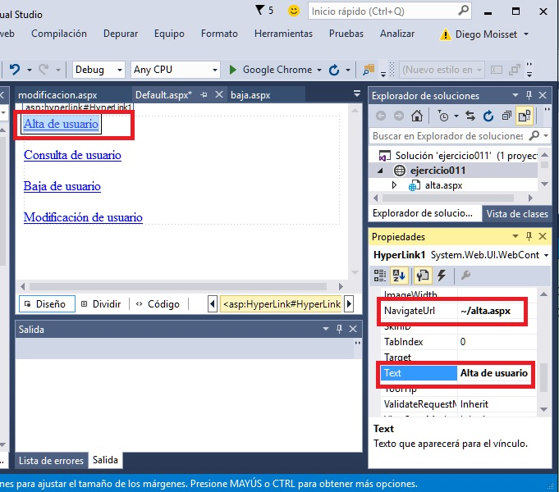

# ALTA

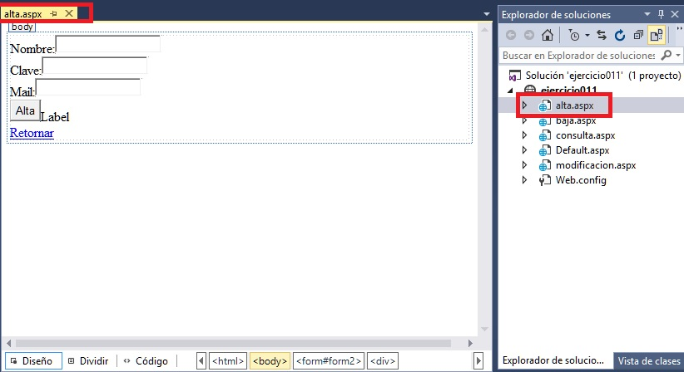

using System;

using System.Collections.Generic;

using System.Data.SqlClient;

using System.Linq;

using System.Web;

using System.Web.UI;

using System.Web.UI.WebControls;

public partial class alta : System.Web.UI.Page

{

protected void Page_Load(object sender, EventArgs e)

{

}

protected void Button1_Click(object sender, EventArgs e)

{

string s = System.Configuration.ConfigurationManager.ConnectionStrings["cadenaconexion1"].ConnectionString;

SqlConnection conexion = new SqlConnection(s);

conexion.Open();

SqlCommand comando = new SqlCommand("insert into usuarios(nombre,clave,mail) values('" +

TextBox1.Text + "','" + this.TextBox2.Text + "','" +

TextBox3.Text + "')", conexion);

comando.ExecuteNonQuery();

Label1.Text = "Se registro el usuario";

conexion.Close();

}

}

# CONSULTA

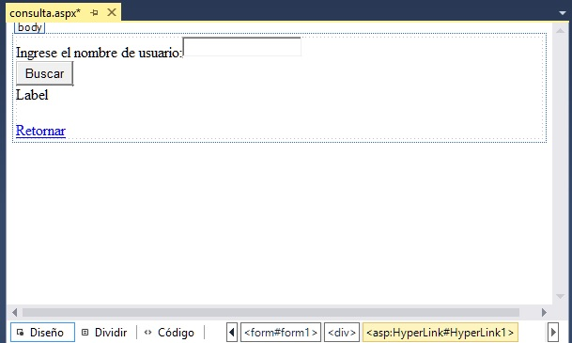

using System;

using System.Collections.Generic;

using System.Data.SqlClient;

using System.Linq;

using System.Web;

using System.Web.UI;

using System.Web.UI.WebControls;

public partial class consulta : System.Web.UI.Page

{

protected void Page_Load(object sender, EventArgs e)

{

}

protected void Button1_Click(object sender, EventArgs e)

{

string s = System.Configuration.ConfigurationManager.ConnectionStrings["cadenaconexion1"].ConnectionString;

SqlConnection conexion = new SqlConnection(s);

conexion.Open();

SqlCommand comando = new SqlCommand("select nombre,clave,mail from usuarios " +

" where nombre='" + this.TextBox1.Text + "'", conexion);

SqlDataReader registro = comando.ExecuteReader();

if (registro.Read())

this.Label1.Text = "Clave:" + registro["clave"] + "<br>" +

"Mail:" + registro["mail"];

else

this.Label1.Text = "No existe un usuario con dicho nombre";

conexion.Close();

}

}

# BAJA

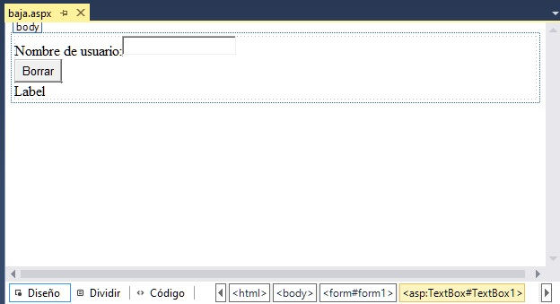

using System;

using System.Collections.Generic;

using System.Data.SqlClient;

using System.Linq;

using System.Web;

using System.Web.UI;

using System.Web.UI.WebControls;

public partial class baja : System.Web.UI.Page

{

protected void Page_Load(object sender, EventArgs e)

{

}

protected void Button1_Click(object sender, EventArgs e)

{

string s = System.Configuration.ConfigurationManager.ConnectionStrings["cadenaconexion1"].ConnectionString;

SqlConnection conexion = new SqlConnection(s);

conexion.Open();

SqlCommand comando = new SqlCommand("delete from usuarios where nombre='" + this.TextBox1.Text + "'", conexion);

int cantidad = comando.ExecuteNonQuery();

if (cantidad == 1)

this.Label1.Text = "Se borró el usuario";

else

this.Label1.Text = "No existe un usuario con dicho nombre";

conexion.Close();

}

}

# MODIFICAR

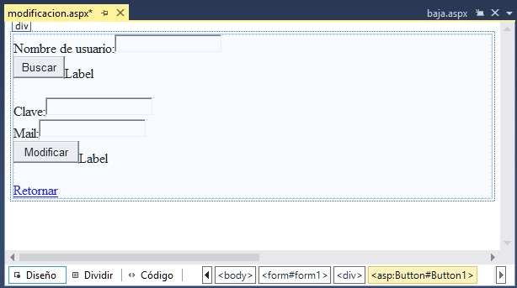

using System;

using System.Collections.Generic;

using System.Data.SqlClient;

using System.Linq;

using System.Web;

using System.Web.UI;

using System.Web.UI.WebControls;

public partial class modificacion : System.Web.UI.Page

{

protected void Page_Load(object sender, EventArgs e)

{

}

protected void Button1_Click(object sender, EventArgs e)

{

string s = System.Configuration.ConfigurationManager.ConnectionStrings["cadenaconexion1"].ConnectionString;

SqlConnection conexion = new SqlConnection(s);

conexion.Open();

SqlCommand comando = new SqlCommand("select nombre,clave,mail from usuarios " +

" where nombre='" + this.TextBox1.Text + "'", conexion);

SqlDataReader registro = comando.ExecuteReader();

if (registro.Read())

{

this.TextBox2.Text = registro["clave"].ToString();

this.TextBox3.Text = registro["mail"].ToString();

}

else

this.Label1.Text = "No existe un usuario con dicho nombre";

conexion.Close();

}

protected void Button2_Click(object sender, EventArgs e)

{

string s = System.Configuration.ConfigurationManager.ConnectionStrings["cadenaconexion1"].ConnectionString;

SqlConnection conexion = new SqlConnection(s);

conexion.Open();

SqlCommand comando = new SqlCommand("update usuarios set " +

"clave='" + this.TextBox2.Text +

"',mail='" + this.TextBox3.Text +

"' where nombre='" + this.TextBox1.Text + "'", conexion);

int cantidad = comando.ExecuteNonQuery();

if (cantidad == 1)

this.Label2.Text = "Datos Modificados";

else

this.Label2.Text = "No existe el usuario";

conexion.Close();

}

}